After you have reached the final step in the game you have created, click on “Run” and then “Finish.”
A new window will open that looks like this:
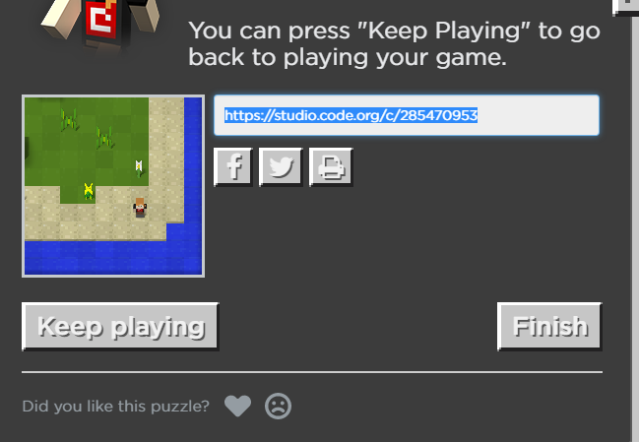
Click on the URL in the middle to select/highlight it and then right-click with your mouse and choose “copy.”
Open your school e-mail and begin a new e-mail to Mr. Hoskins. In the message, right-click with your mouse and choose “paste.” This will paste the game into the e-mail and then I will put it in a document to share with all students.

